**PFB the output. I have also attached the queries for all the questions in (.sql) format in the repository link and send as attachment in the mail.**

**MsSQL server has been used to tackle the below questions.**

**Question 1**

Creating table XXBCM_ORDER_MGT

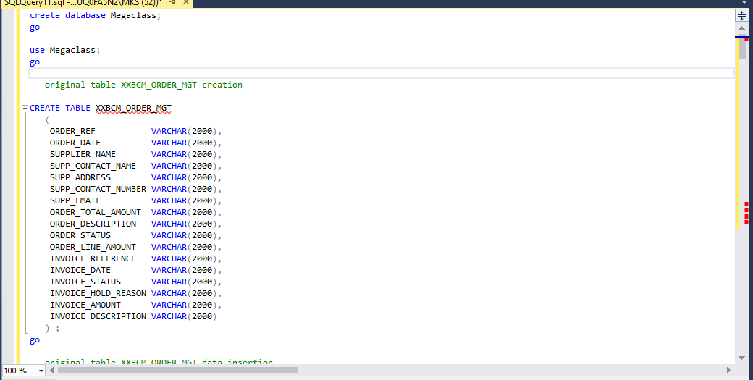

Inserting records in original table XXBCM_ORDER_MGT

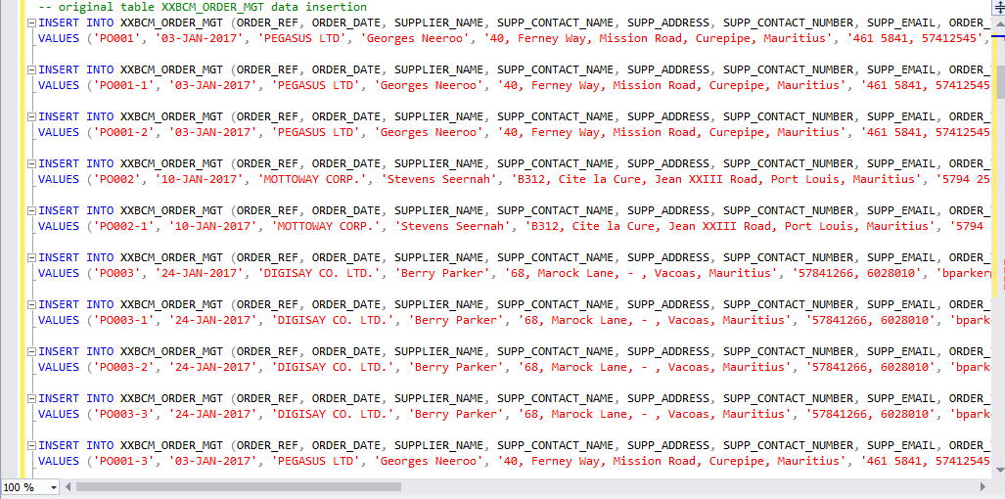

Table XXBCM_ORDER_MGT

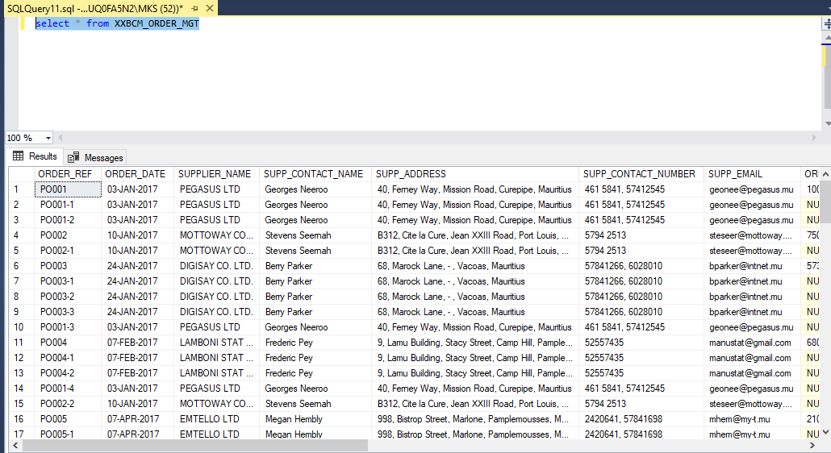

**Question 2**

Designing database schema

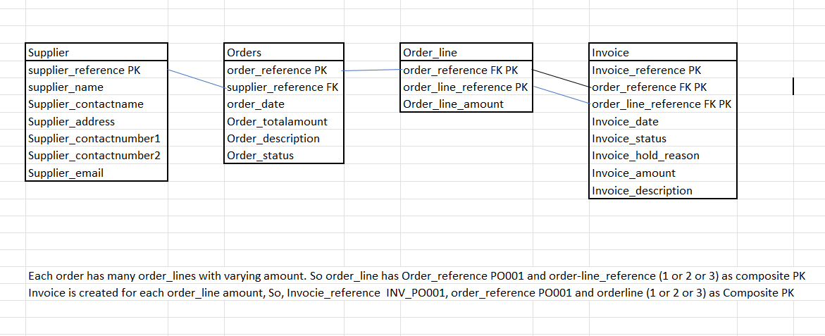

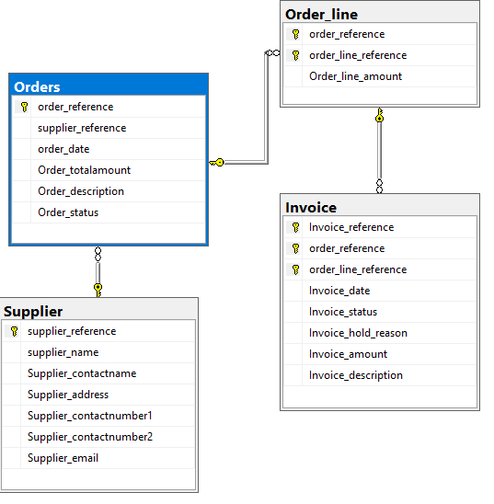

Creating table based on database schema

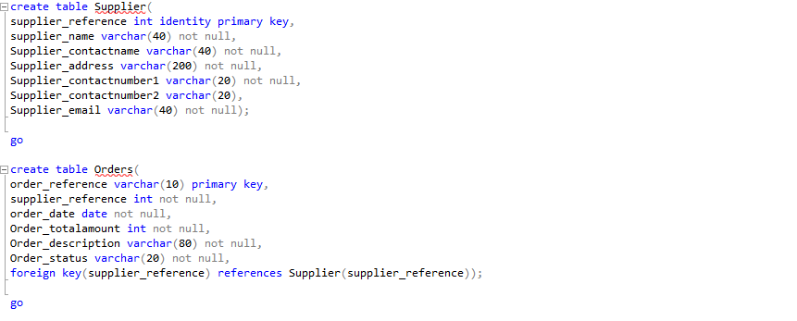

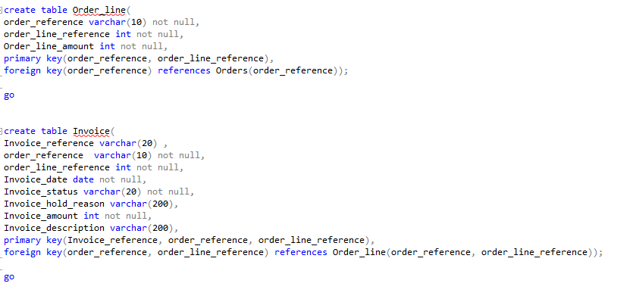

**Question 3**

Store procedure for data migration

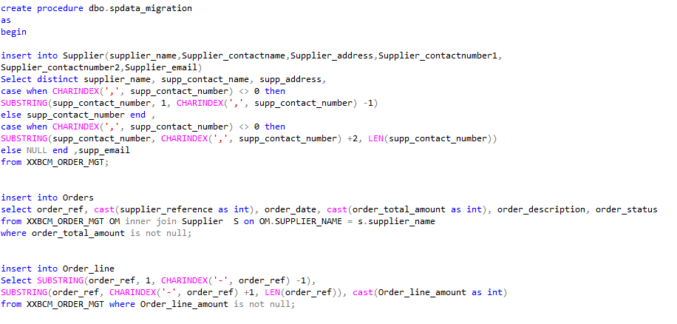

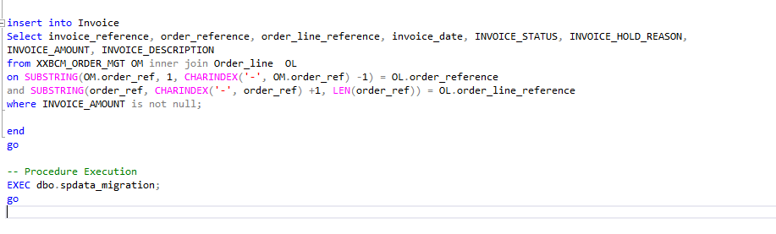

Output of different tables

Table Orders

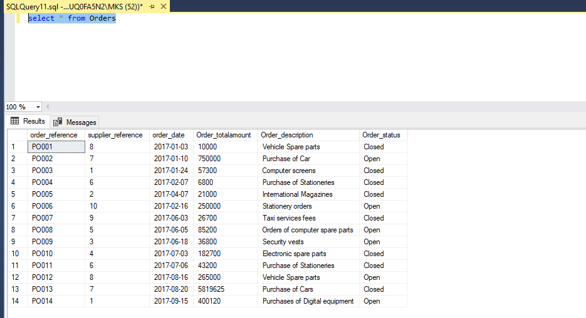

Table Invoice

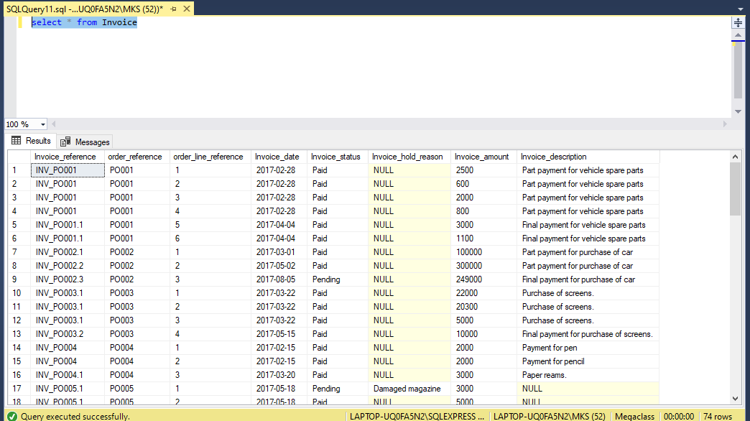

Table Supplier

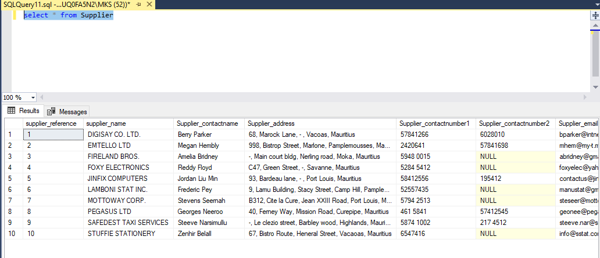

Table Order_Line

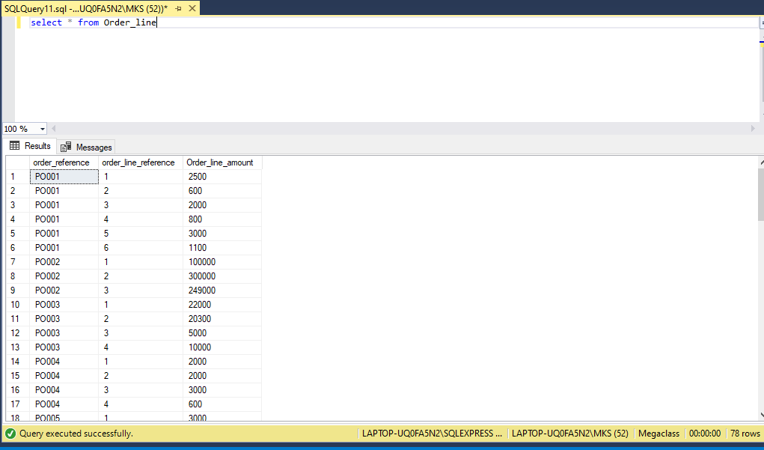

**Question 4**

Store procedure – for question 4

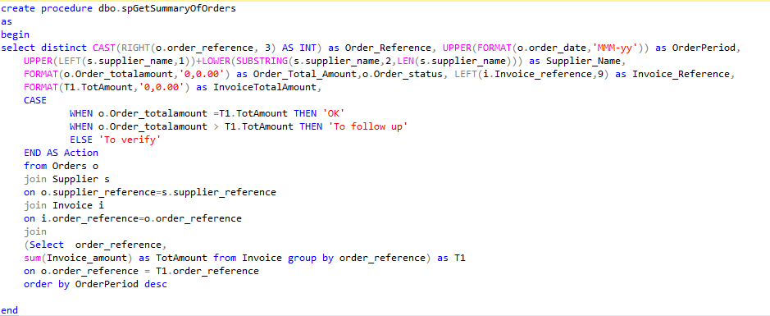

Output for question 4

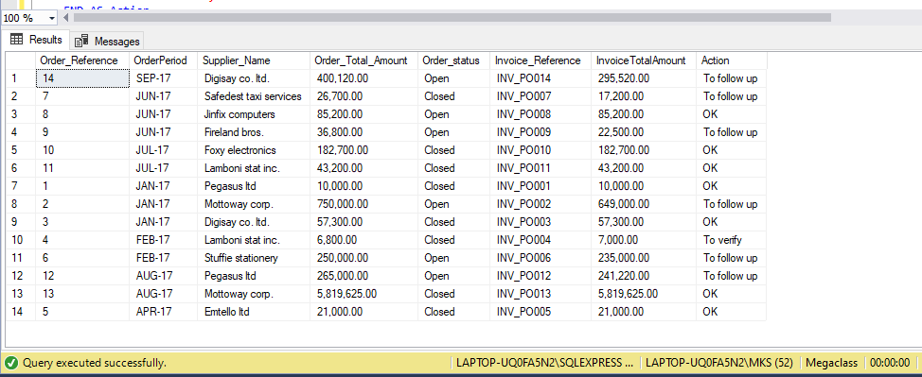

**Question 5**

Store procedure for question 5

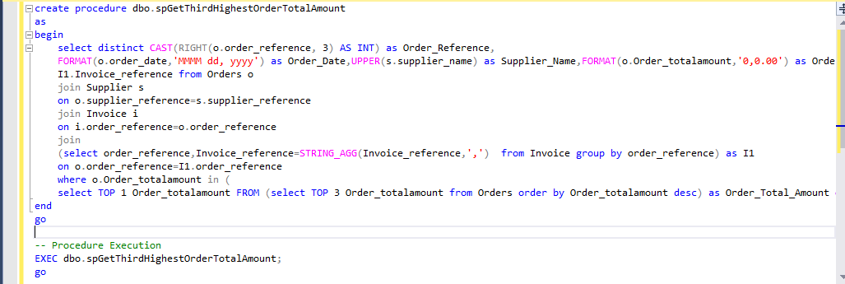

Output for question 5

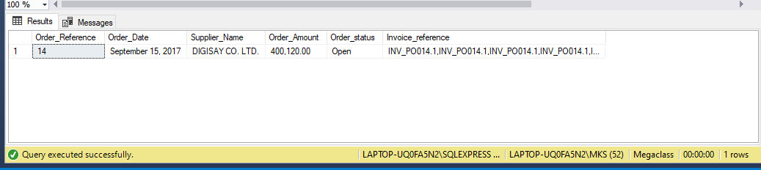

**Question 6**

Store procedure for question 6

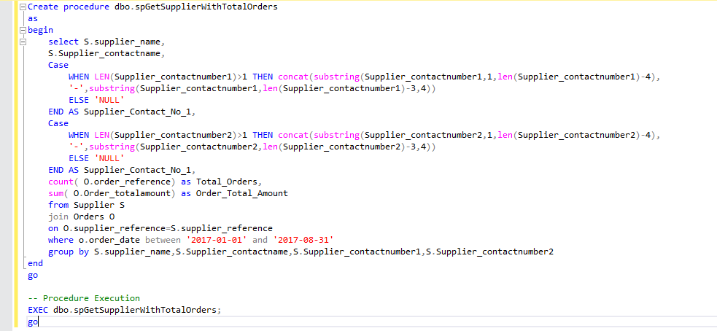

Output for question 6

